Venous Leg Ulcer (VLU) Guide

Background:

NHS England undertook a process to review PMS practices with a view to ensuring equitable funding per patient across GMS & PMS practices. As a consequence of this it further highlighted a number of services general practice provides which were not included as Essential or Additional Services.

When working through the process, leg ulcers was a recurring theme that cropped up in most of our CCG areas. The main issue was at what point should general practice be funded to provide a leg ulcer service.

Purpose:

This document provides the Wessex LMCs view as to what is Essential Services and what is an LCS in relation to Venous Leg Ulcers (VLU). It also provides our view on:

- the management of leg ulcers within general practice
- best practice with the emphasis on long term patient education to maintain a ‘healthy leg’

This document has been compiled in line with NICE guidance for Venous Leg Ulcers (February 2016) and Best Practice Statement Holistic Management of Venous Leg Ulcers (November 2016). These can be accessed via http://cks.nice.org.uk/leg-ulcer-venous or http://www.wounds-uk.com/best-practice-statements/best-practice-statement-holistic-management-of-venous-leg-ulceration. Practices may wish to refer to the Leg Ulcer Treatment pathway on page 15 within the Best Practice Statement document.

The costings element of the guide has been based on Agenda for Change bands with a range provided. This is in acknowledgement that the different components may be undertaken by a General Practice Nurse (GPN) or Healthcare Assistant (HCA) who have undertaken recognised training within this area of specialism.

Definition:

“A leg ulcer is defined as the loss of skin below the knee on the leg or foot which takes more than 2 weeks to heal”. (NICE guidance - https://cks.nice.org.uk/leg-ulcer-venous#!backgroundsub )

Context:
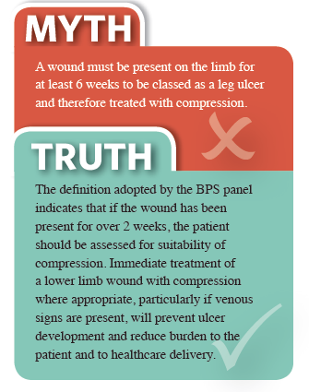
- VLUs are the most common type of leg ulcer (SIGN 2010)
- There are at least 730,000 patients with leg ulcers in the UK (Guest Et al 2015)
- 1.5% of the adult population has a leg ulcer
- The number of diagnosed VLUs (278,000) indicates 1 in 170 adults have a VLU

VLUs have been found to have a significant impact on patients’ quality of life, with associated personal, social
and psychological effects; this also has a considerable financial impact on healthcare providers as well as a
wider social and economic impact (EWMA, 2016).

Guide:
The guide provides the four stages of managing VLUs with the aim to help commissioners and ultimately practices deliver a cost effective service, based on best practice. It also provides information on the actions general practice need to take for other types of leg ulcers.

Please note the length of appointment times are not included within NICE guidance or the Best Practice Statement however we have consulted with GPs, GPNs and experts in this field to identify these.

1 Identification of Need Essential Services

An initial consultation with a GP or GPN with guidance on what to assess as per boxes below. This has been taken from the Best Practice Statement: Holistic Management of VLUs 2016.
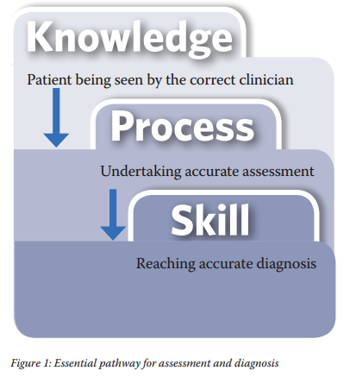

- General Assessment, including medical/family history, & lifestyle/psychosocial issues
- Wound/skin assessment

- Patient seen for a 2 week period as needed, unless an obvious ulcer (e.g. arterial/venous) in which case they move straight to level 2
- If the wound is not healed after 2 weeks patient moves to level 2
- Further information on examination of legs can be found at https://cks.nice.org.uk/leg-ulcer-venous#!diagnosissub:1

2 Assessment & Investigations - Healthcare Professional LCS

ABPI (Doppler) procedure can be undertaken by a GPN or a trained & assessed as competent HCA. The interpretation of the ABPI should be undertaken by GPN or GP https://cks.nice.org.uk/leg-ulcer-venous#!diagnosissub:2

As part of the general assessment a holistic approach will include: psychosocial and lifestyle factors, overall health, any underlying causes or relevant medical history and quality of life. Please refer to box 3 and page 4 of Best Practice Statement: Holistic Management of VLUs (2016)

Consider further investigations if an alternative or additional cause for the ulcer is suspected

This appointment is likely to be a minimum of 1 hour for one leg, if both legs this will be a minimum of 1 ½ hours
Diagnosis: Arterial Leg Ulcers refer to specialist service
Mixed (venous & arterial components) Leg Ulcers refer to specialist service for further investigation & care
Venous Leg Ulcers (VLUs) once diagnosed should be classified as simple or complex. Complex VLUs should be managed by specialist wound management services depending on local provision.

Cost (excludes cost of dressings): £20.74 – £31.83 per assessment (Based on a range between band 5 – 7 dependent on experience of Nurse/HCA)

Cost for both legs (excludes cost of dressings): £31.11 – £47.75

(Please note the costings for both legs have been based on the cost of one leg, with timings adjusted)

Identified Lead:
Given that all leg ulcers are complex it is advisable that there is an identified lead for each patient to oversee their care. This does not necessarily mean they have to see that person every time for a dressing, the lead would be responsible for ensuring they leg ulcer is healing and referral onwards should this not be the case.

3 Treatment & Management – Healthcare Professional LCS

All VLUs should be managed by using a structured assessment method such as the TIMES framework (Tissue, Infection, Moisture, Edge of wound, Surrounding Skin). This can be found on page 8 and table 3 in the Best Practice Statement: Holistic Management of VLUs 2016 document. The patient should be involved in all stages of treatment including education on lifestyle and mobility, adopting a holistic person-centred approach (pg. 18 Best Practice Statement Holistic Management of VLUs 2016).

Appointments likely to be a minimum of 45 minutes and if both legs this will be at least 1 ½ hours. Dressings may be more frequently than once a week - https://cks.nice.org.uk/leg-ulcer-venous#!scenario

At a minimum of 4 weekly intervals all leg ulcers should be assessed for size, progress & healing.

After 4 weeks of treatment, if no reduction of ulcer size or deterioration consider referral to vascular or tissue viability service (page 15 –algorithm), Best Practice Statement Holistic: Management of VLUs 2016

If not healing after 12 weeks, reassessment to include APBI and refer to tissue viability service/specialist leg ulcer clinic (https://cks.nice.org.uk/leg-ulcer-venous#!scenariorecommendation:1 refer to section titled ‘Infection’)

Cost (excludes cost of dressings): £15.55 - £23.87 per treatment (Based on a range between band 5 – 7 dependent on experience of Healthcare Professional).

Cost of both legs (excludes cost of dressings): £31.11 – £47.75

(Please note the costings for both legs have been based on the cost of one leg, with timings adjusted)

Reassessment of non-healing leg ulcer costs: as identified in section 2

4 Maintenance Phase of Management – Healthcare Professional LCS

The aim of the maintenance phase is to educate the patient/carer around the importance of adherence to treatment, to increase their confidence around self-management, to recognise signs of deterioration and self-refer within 2 weeks.

These appointments are usually a minimum of 30 minutes and if both legs this will be 1 hour (additional time if an ABPI is required).

Review of patient at 3, 6 & 12 months and then annually when the maintenance phase has begun, depending on the patient risk this could include a reassessment with an ABPI which may take a minimum of 45 minutes

This should be undertaken by a GPN or HCA who has received training and is assessed as competent in the recognition of venous disease and any deterioration. This is to optimise treatment, management and early intervention.

Costs (one leg): £10.37 - £15.92 per maintenance appointment (Based on a range between band 5 – 7 dependent on experience of Healthcare Professional).

Costs (both legs): £20.74 – 31.83 per maintenance appointment (Based on a range between band 5 – 7 dependent on experience of Healthcare Professional).

(Please note the costings for both legs have been based on the cost of one leg, with timings adjusted)

Cost associated with ABPI – these can be found in section 2
In some areas patients can access additional support through Leg Clubs. This can be a cost-effective model of long term care, for further information click on this link: http://www.legclub.org/commissioners

Training & Competence

Commissioners & Providers should ensure that all GPNs and HCAs have undertaken recognised training with regular updates within this area of specialism.

Wessex LMCs offer training on assessment, ABPI and compression bandaging. Further information can be found on our website (https://www.wessexlmcs.com/)

References

http://cks.nice.org.uk/leg-ulcer-venous

http://www.wounds-uk.com/best-practice-statements/best-practice-statement-holistic-management-of-venous-leg-ulceration.

